
OREGON STATE UNIVERSITY RESIDENCY AFFIDAVIT HOW TO GUIDE
1

TABLE OF CONTENTS
Overview...3
Financially Independent Students...5 Financially Dependent Students...8 Active Military Duty...11 Veterans...11
Tribal Affiliation...12
Navigating to the DocuSign Form...15 Filling out the DocuSign Form...18
Overview
This information is for admitted OSU students who are currently being assessed non-resident tuition and think they meet the Oregon Residency Standards criteria to be considered for resident tuition. Full criteria may be found on the residency website: https://admissions.oregonstate.edu/residency
If you think you meet the criteria, the next step is to fill out a DocuSign residency affidavit. This can be found in your student self-service portal. Tips on how to fill out the DocuSign form are at the end of this document.
Please follow the steps below carefully.
It is important to fill out the affidavit accurately. Keep in mind that when you sign and submit your residency affidavit, you are attesting that all the information supplied by you in your affidavit is complete, true and correct. Filling out your affidavit accurately will also allow our office to advise you appropriately and can save you time in the affidavit review process.
When you are submitting a residency affidavit, the first thing you need to determine is if you have been financially independent or financially dependent for the 12 months preceding submission of your residency affidavit.
You are considered financially independent for residency purposes if you:
- Are NOT claimed as a dependent on state and/or federal taxes in the immediately preceding tax year, will not be claimed as a dependent during the current tax year AND/OR
- Did not receive more than half of the support necessary to cover your expenses for the last calendar year, in cash or in kind, from another person or through school related aid such as Grants, Student Loans, or Scholarships
Or
- You are married

You are considered financially dependent for residency purposes if you:
- Are claimed as a dependent on taxes in the immediately preceding tax year or current year, you are considered financially dependent on the person claiming you
AND
- If your calculated earnings from your wages, unemployment benefits, or personal loans is less than half of your total expenses for the year, you would not be considered financially
independent and should fill out the affidavit as a financially dependent student. (If you are not claimed as a dependent on taxes in the immediately preceding tax year or current year, your next step is to estimate your total expenses for the calendar year)
Calculating Financial Expenses (related to Number 12a on the Residency Affidavit form):
  - The Residency Office does not need an exact number, but, to the best of your ability, esti-mate the total monetary cost or value of the following for the 12-consecutive month
period: Tuition, rent, utility bills, phone bills, internet bills, groceries, gas, entertainment, clothes, car insurance, renters’ insurance, etc. (For example, if you do not pay rent, think about roughly how much your living situation would cost if someone were paying for it. For example, a typical room rental in Corvallis, OR, might go for around $500/month at a minimum).
Determining Financial Resources (related to 12b on the Residency Affidavit form):
  - Next, determine how much you have earned through wages, unemployment benefits, or personal loans you have received for the 12-consecutive month period. If this amount is less than half of your total expenses for the year, you would not be considered financially
independent and should fill out the affidavit as a financially dependent student
  - If you provided more than half of your own financial resources for the past 12 months, please fill out the affidavit as a financially independent student

FINANCIALLY INDEPENDENT STUDENTS


Section 1
Number 1: Please fill this in with the term you are seeking residency classification keeping in mind that you cannot select a term for which the residency affidavit deadline has passed.
Number 2-8: Fill this information out accurately
Number 9: If you do not know what these terms are, or have not attended any institution in Oregon, this likely does not apply to you, and you can select “No”.
Number 10: If you are not a citizen of the USA, be sure to submit a copy of your Permanent Resident Card, I-94 form, or other documentation reflecting your visa type or current immigration status with your affidavit.
Number 11: Examples of state or government assistance might include food stamps, unemployment, disability, COVID stimulus checks, etc.
Number 12a: Enter the amount you calculated in this field for your total expenses. This specifically refers to your financial expenses for the past 12-consecutive month period (not just a single month total). Please note that $0 is not an appropriate answer. Please accurately estimate your total financial expenses (even if you were not the one paying them, i.e., your parents/guardians pay your utilities).
Number 12b: Fill out this table as completely as possible. This table represents the financial resources/sources that were used or received for the 12-consecutive month period. Student loans should go in the “Other sources of support”. You will likely be asked to provide documentation of the support indicated in this section. This might include W2 statements, cancelled checks or wired transfers from parents, and documentation of any loans you have taken out. It is important to know we ask that you redact ALL bank account numbers or identifying information apart from names before submitting any such information.

You may also submit any sale of personal or real property, inheritance, trust fund information, gifts, or other earnings.

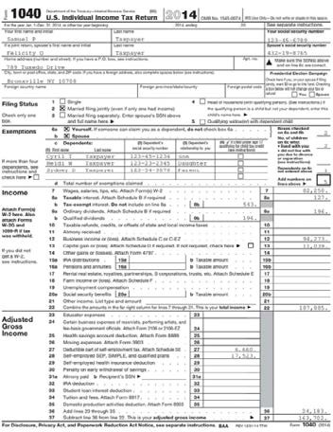
Section 2
Number 1-5: Fill this out accurately
Number 6: If you own your house, please submit the first 1 or 2 pages of your home purchase agreement showing your name, the home address, and the date of purchase. In addition, please submit some supporting documentation showing continued presence at that location as needed, which may include property tax statements or utility bills. These should include the date, your name, and the home address.
If you rent your home, please submit only the first 2-5 pages of your rental or lease agreement showing your name, the home address, and the dates of the rental agreement. If you do not have a rental agreement, you might also submit letters from your landlord or cancelled checks.
Please redact any social security numbers or bank account information if they are present on any of this documentation.
If you are/were experiencing housing insecurity during the 12-month period of time when you are attempting to establish residency, please submit a word document briefly explaining this.
Number 7-8: Fill this out as accurately as possible.
Number 9: We understand voter registration cards are not available in every state. A screenshot or any document showing your name and the state you are registered to vote in will be sufficient.

Number 10-11: Please submit the most recent version of these documents. Number 12: Please see the section above on taxes.
Number 13-14: Please answer these as accurately as possible.
The notary requirement is permanently waived. Please sign the document here.
You will be asked to submit a copy of your state and federal tax returns for the immediately preceding year. We do not need more than the first 2-5 pages for each of these documents. For federal taxes, this form is the 1040, which looks like this:

We will need the similar section for state tax returns, showing exemptions and dependents. You must redact ALL social security numbers on this document before submitting. You are also welcome to redact the names of any other individuals on this document.
If you are under the age of 24, you must also submit the same documents of your parents or legal custodian. Again, please redact all social security numbers on these documents, which should be no more than 2-5 pages long each.
We understand Washington residents will not have state tax returns. If your state does not require taxes, please upload a 1-2 sentence statement in the state tax section of the affidavit explaining this.


FINANCIALLY DEPENDENT STUDENTS

Section 1
Number 1: Please fill this in with the term you are seeking residency classification keeping in mind that you cannot select a term for which the affidavit deadline has passed.

Number 2-8: Fill this information out accurately.

Number 9: If you do not know what these terms are, or have not attended any institutions in Oregon, this likely does not apply to you, and you can select “No.”

Number 10: If you are not a citizen of the USA, be sure to submit a copy of your Permanent Resident Card, I-94 form, or other documentation reflecting your visa type or current immigration status with your affidavit

Number 11: Examples of state or government assistance might include food stamps, unemployment, disability, COVID stimulus checks, etc.

Number 12a: Enter the amount you calculated in this field for your total expenses. This specifically includes your financial expenses for the past 12-consecutive month period (not a single month period). Please note that $0 is not an appropriate answer, even if you are financially dependent. Please include an accurate estimate of your total financial expenses (even if you were not the one paying them, i.e., your parents/guardians pay your rent and tuition).

Number 12b: Fill out this table as completely as possible. This table represents the financial resources/sources that were used or received for your financial expenses. Student loans should go in the “Other sources of support”. If you are not claimed as a dependent on taxes for the immediately preceding tax year, you will likely be asked to provide documentation of the support indicated in this section. This might include W2 statements, cancelled checks or wired transfers from parents, and documentation of any loans you have taken out. It is important to know we ask that you redact ALL bank account numbers or identifying information apart from names before submitting any such information. You may
also submit any sale of personal or real property, inheritance, trust fund information, gifts, or
other earnings

Section 2
Number 1-5: Your parent or the person upon whom you are financially dependent should fill this out as accurately providing their information (not the student’s information). This is not to be completed by a spouse.
Number 6: If your parent or legal guardian owns their house, please submit the first 1 or 2 pages of their home purchase agreement showing their name, the home address, and the date of purchase. In addition, please submit some supporting documentation showing continued presence at that location as needed, which may include property tax statements or utility bills. These should include the date, your parent or legal guardian’s name, and the home address.

If your parent or legal guardian rents their home, please submit the first 2-5 pages of their rental or lease agreement showing their name, the home address, and the dates of the rental agreement you. If your parent or legal guardian does not have a rental agreement, you might also submit letters from your landlord or cancelled rent checks.
Please redact any social security numbers or bank account information if they are present on any of this documentation.
If you are/were experiencing housing insecurity during the 12-month time period when you are attempting to establish residency, please submit a word document briefly explaining this.

Number 7-8: Your parent or legal guardian should fill this out accurately.
Number 9: We understand voter registration cards are not available in every state. A screenshot or any document showing your parent or legal guardian’s name and the state they are registered to vote in will be sufficient.
Number 10-11: Please submit the most recent version of these documents. Number 12: Please see the section above on taxes.
Number 13-14: Please answer these accurately.

You will be asked to submit a copy of your parent or legal guardian’s state and federal tax returns for the immediately preceding year. We do not need more than 2-5 pages for each of these documents. For federal taxes, this form is the 1040, which looks like this:
We understand Washington residents will not have state tax returns. If your state does not require taxes, please upload a 1-2 sentence statement in the state tax section of the affidavit explaining this.

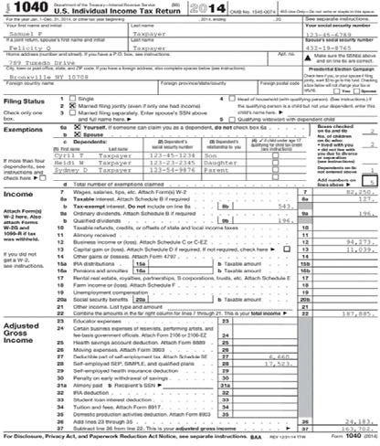
You must redact ALL social security numbers on this document before submitting. You are also welcome to redact the names of any individuals other than yourself and your guardian(s) on this document. You are also welcome to redact the income listed on this document if you would like.
We will need the similar section for state tax returns, showing exemptions and dependents. You must redact ALL social security numbers on this document before submitting. You are also welcome to redact the names of any other individuals on this document.

ACTIVE DUTY MILITARY
Please fill out the affidavit depending on your financial status (independent or dependent)
above. In addition, please submit a copy of your order assigning you to active duty.



VETERANS
Please fill out the affidavit depending on your financial status (independent or dependent)
above. In addition, please submit a copy of your DD-214 and documentation of re-established domicile in Oregon.

TRIBAL AFFILIATION
Regardless of if you are financially dependent or independent, use this form. Simply fill out the 1-page
affidavit. Then, with the affidavit, submit a copy of your Tribal Enrollment Confirmation. You do not need to submit any other documentation.
- Login to your Beaver Hub account
  - https://beaverhub.oregonstate.edu/s/

  - Or access through https://oregonstate.edu under “Menu”



- Navigate to the search bar



- Type in “Residency” into the search bar
- This should lead you to a screen that lists the link to the Oregon Tribal Residency Affidavit



- Click on the Direct Link to the Tribal Residency Affidavit (Note that the Tribal Affidavit should only be selected if you are a member of one of the 574 recognized Tribes)
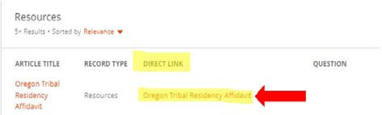

- After selecting the Tribal Residency Affidavit form, you will be presented with a message that displays “DocuSign Form Submission” confirming your name and OSU email, with the message, “Initiate Request” or “Return to OSU Homepage”:
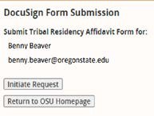

- Click “Initiate Request” (this will send you an email confirming you have begun the affidavit process)

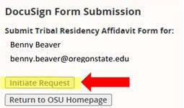
NAVIGATING TO THE DOCUSIGN FORM

- You can proceed with the affidavit immediately by selecting “click here to sign Oregon Tribal Residency Affidavit Form Now,” or you can navigate back to the affidavit at any time, using the email which will be sent to your OSU-issued email address.



Alternatively, you can go to your OSU-issued email inbox and locate an email from DocuSign and fill out the DocuSign Residency Affidavit form that way instead:
- Login to your Beaver Hub account
  - https://beaverhub.oregonstate.edu/s/
  - Or access through https://oregonstate.edu under “Menu”


- Navigate to the search bar



- Type in “Residency” into the search bar

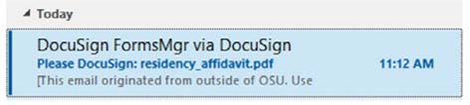
- This should lead you to a screen that lists links to the Oregon Tribal Residency Affidavit, Oregon Residency Affidavit (Independent), and Oregon Residency Affidavit (Dependent)

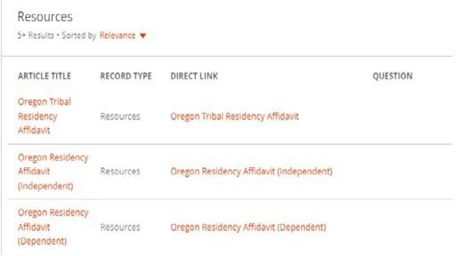

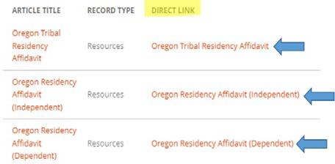
- Click on the Direct Link to the Affidavit that applies to your situation. (Note that the Tribal Affidavit should only be selected if you are a member of one of the 574 Federally recognized Tribes).
- After selecting a Residency Affidavit form,
you will be presented with a message that displays “DocuSign Form Submission” confirming your name and OSU email, with the message “Initiate Request” or “Return to OSU Homepage”:
- Click “Initiate Request” (this will send you an email confirming you have begun the affidavit process)

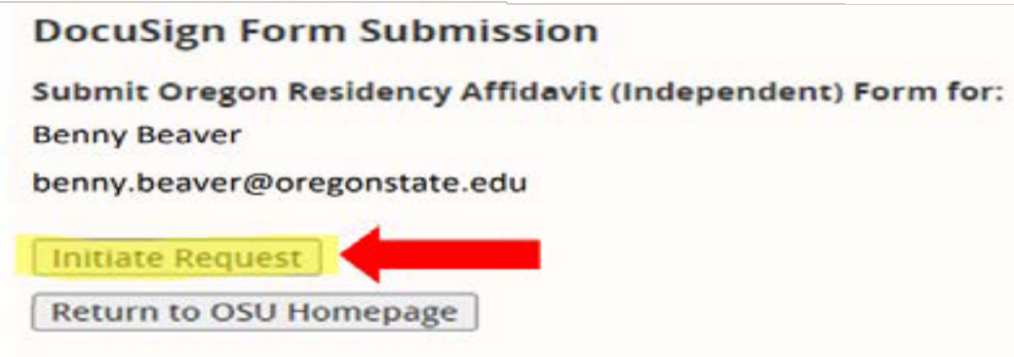

You can begin filling out the Residency Affidavit Form by continuing in the self-service portal by clicking “Click Here to Sign Admissions Residency Affidavit (in/Dependent) Form Now)”:

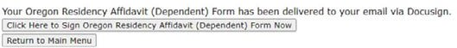

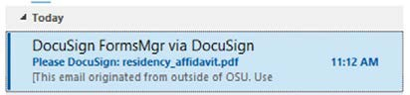
Alternatively, you can go to your OSU-issued email inbox and locate an email from DocuSign and fill out the DocuSign Residency Affidavit form that way instead:


FILLING OUT THE DOCUSIGN FORM
Step 1: Login to DocuSign with your OSU email address
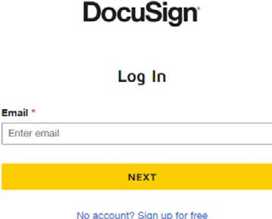

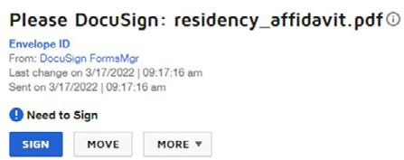
Step 2: Click “Sign”

Step 3: Read the message at the top, then click “Continue”



Step 4: Fill out pages 2 & 3 of the affidavit. Some fields are mandatory, and some require documentation. Use the previous information in this guide to assist you in determining which documents you should attach.

Step 5: If you are financially independent, fill out pages 4 & 5, then click “finish.”
If you are financially dependent, click “finish.” You will be sent an additional email which will ask you to enter the email address for the person you are dependent on as the next “Responsible Person.” Be sure to enter this email address correctly so that the DocuSign form can route to this person. When you click “send,” the affidavit will be directed to this individual to complete their section of the DocuSign form and to attach their required documentation.

Step 6: If you are financially independent, you should receive two emails confirming receipt of your affidavit. One will come from DocuSign, and one will come directly from the residency office.
If you are financially dependent, your “Responsible Person” should click “finish” to finalize the affidavit. You will then receive two emails confirming receipt of your affidavit. One will come from DocuSign, and one will come directly from the residency office.

Step 7: The residency office will be emailing you at your OSU-issued email address to request additional information, or to let you know if a determination has been reached.

THANK YOU FOR REVIEWING THE OSU RESIDENCY AFFIDAVIT
20
HOW TO GUIDE.
IF YOU HAVE ANY QUESTIONS, PLEASE EMAIL THE RESIDENCY

OFFICE AT: RESIDENCY@OREGONSTATE.EDU

